**India’s Agricultural Crop Production Analysis (1997 – 2021)**

**PROJECT REPORT**

# **INTRODUCTION**

**1.1 Overview**

This report delves into the captivating realm of India’s agricultural

cultivation, providing a comprehensive visual exploration of key aspects

and trends in the agricultural sector. Through the visual representations,

readers can gain valuable insights into crop production, seasonal

variations, regional distribution, and overall production trends. These

visualisations enable intuitive analysis, allowing stakeholders to uncover

patterns, identify areas of growth or concern, and make data-driven

decisions.

**1.2 Purpose**

Crop production is a common agricultural practice followed by

worldwide farmers to grow and produce crops to use as food and fibre.

This project includes all the feed sources that are required to maintain

and produce crops, so they can increase their yield production using this

data.

**2 Problem Definition & Design Thinking**

**2.1 Empathy Map**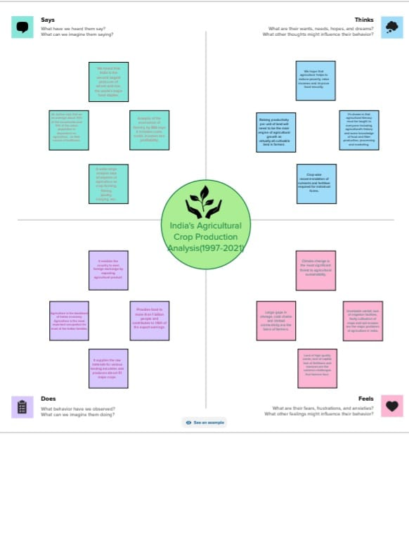

**2.2 Ideation & Brainstorming Map**

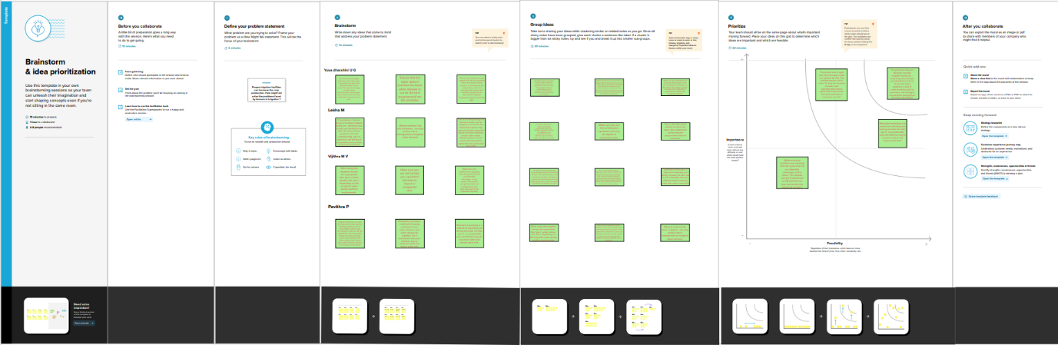

**3 RESULT**

**3.1 Data Model**

**3.1.1 Dashboard**

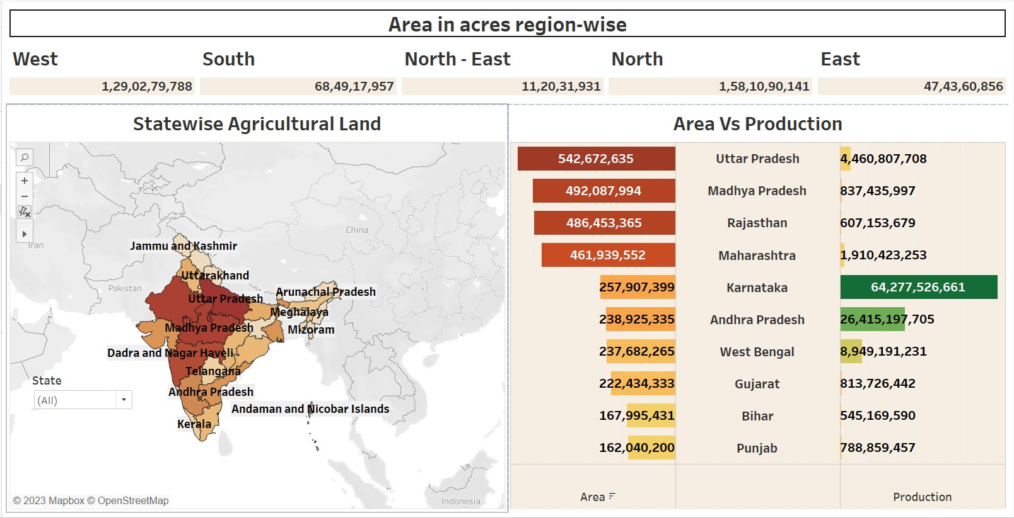

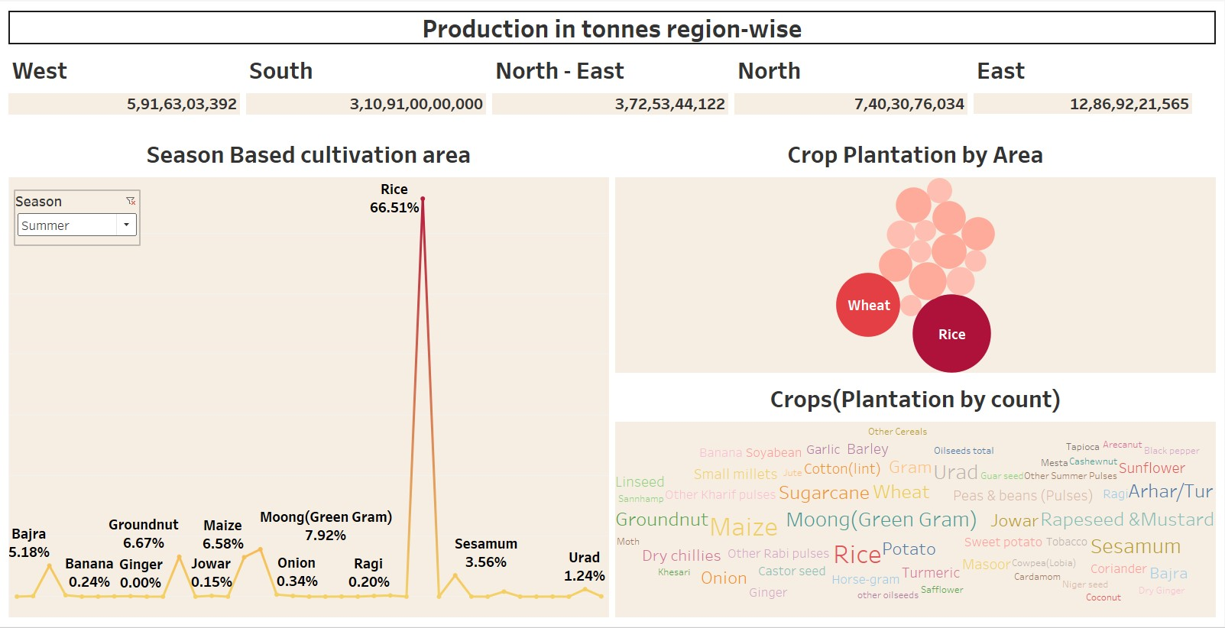

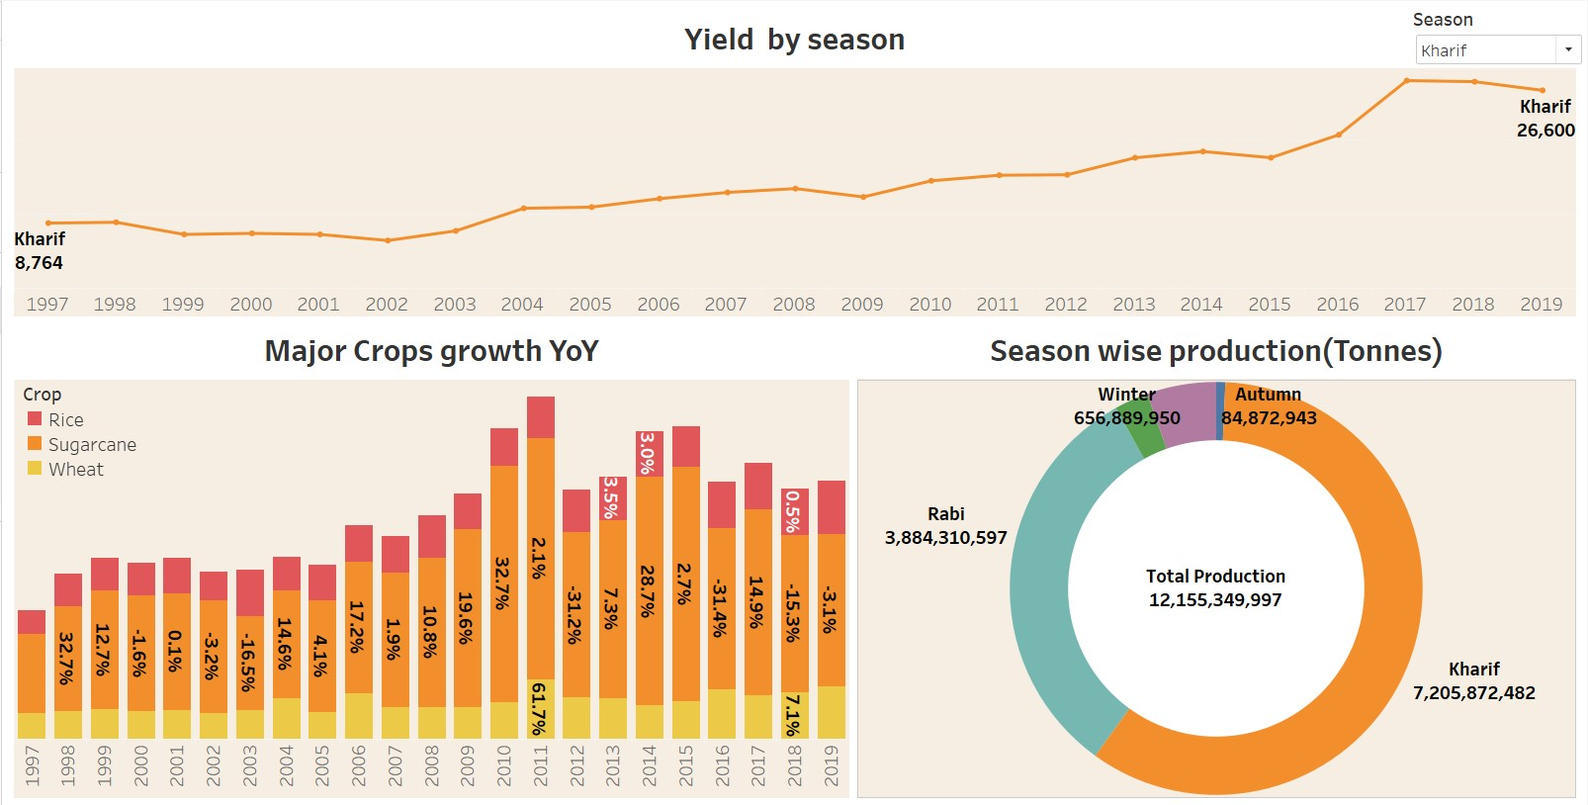

**3.1.2 Story**

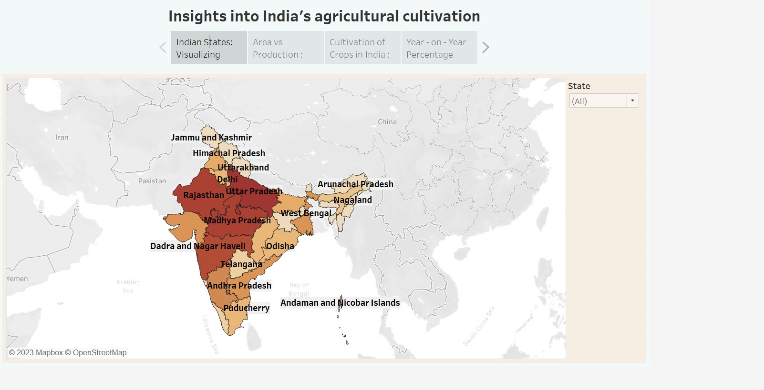

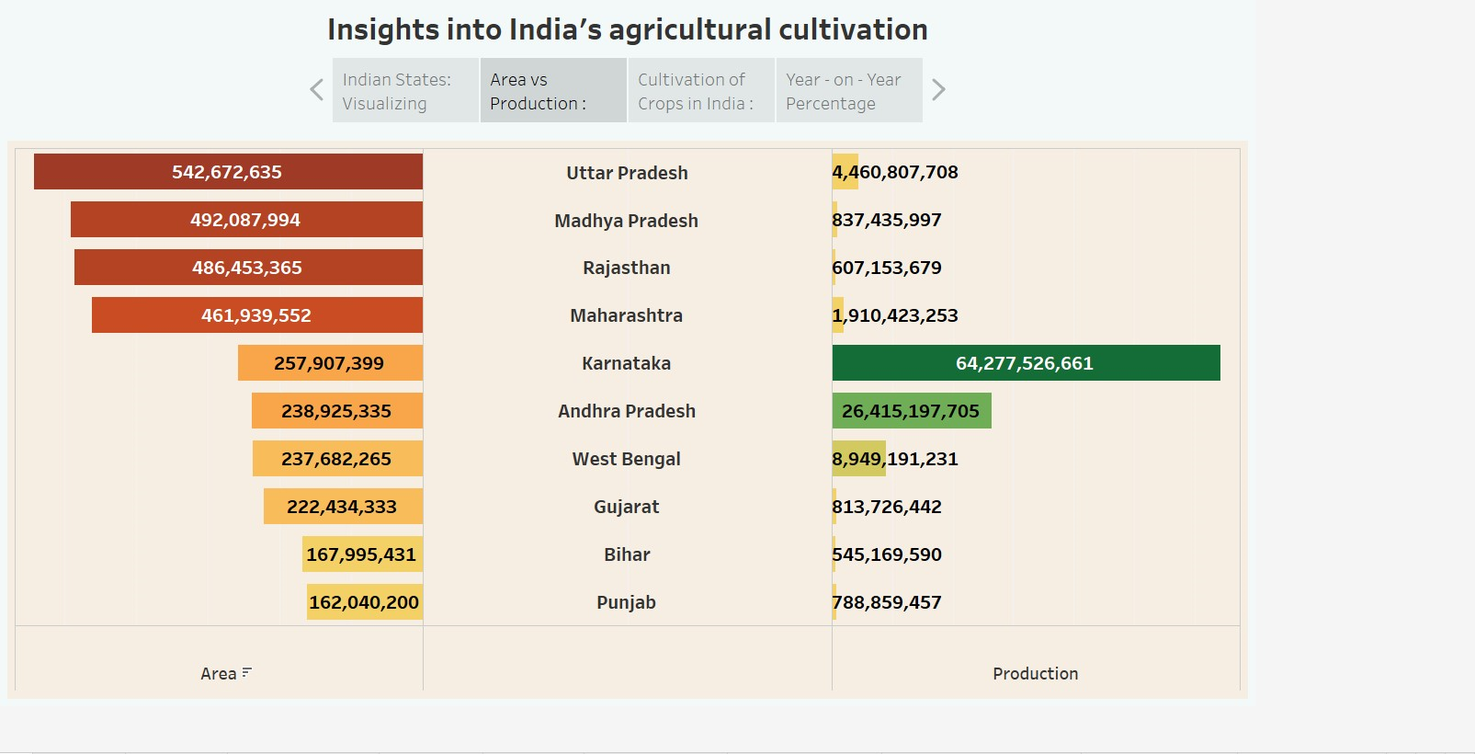

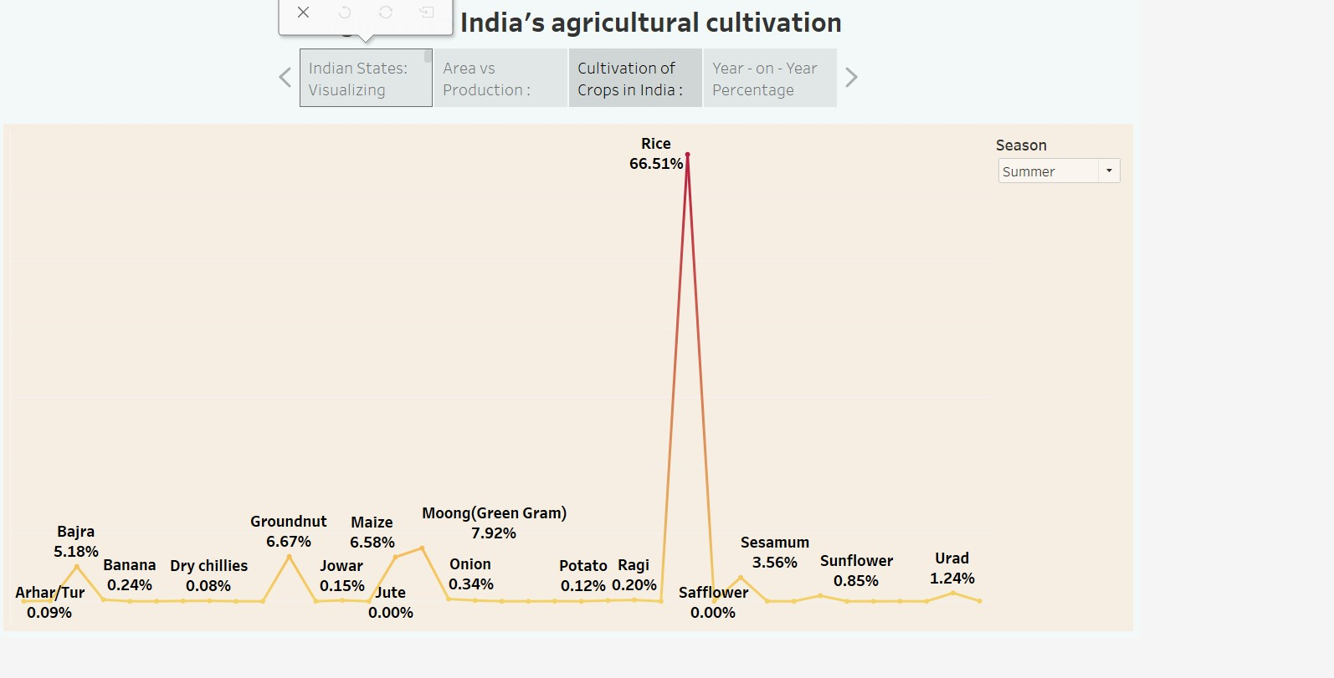

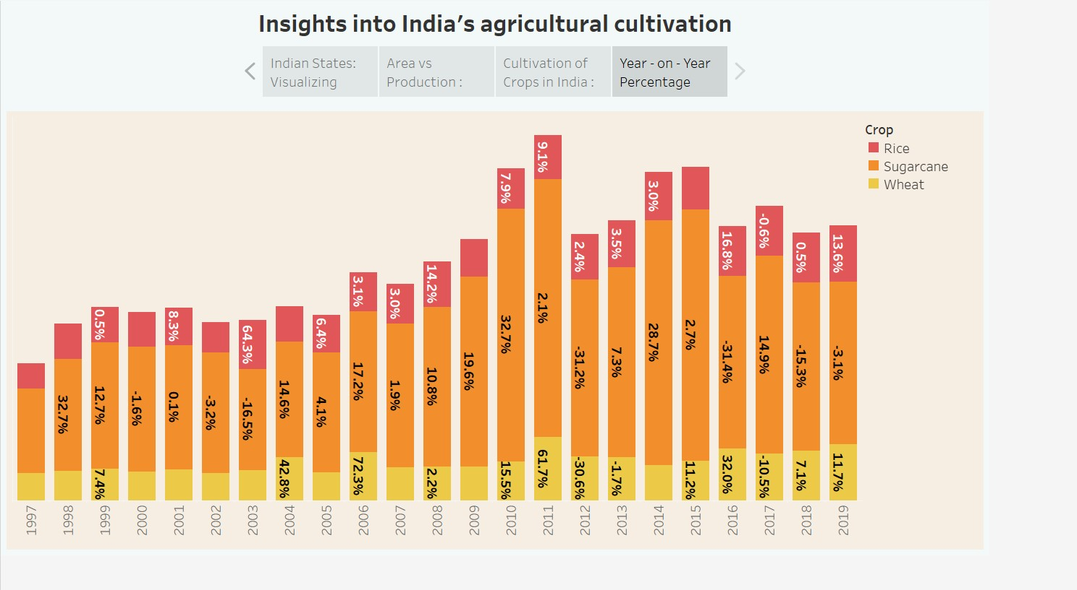

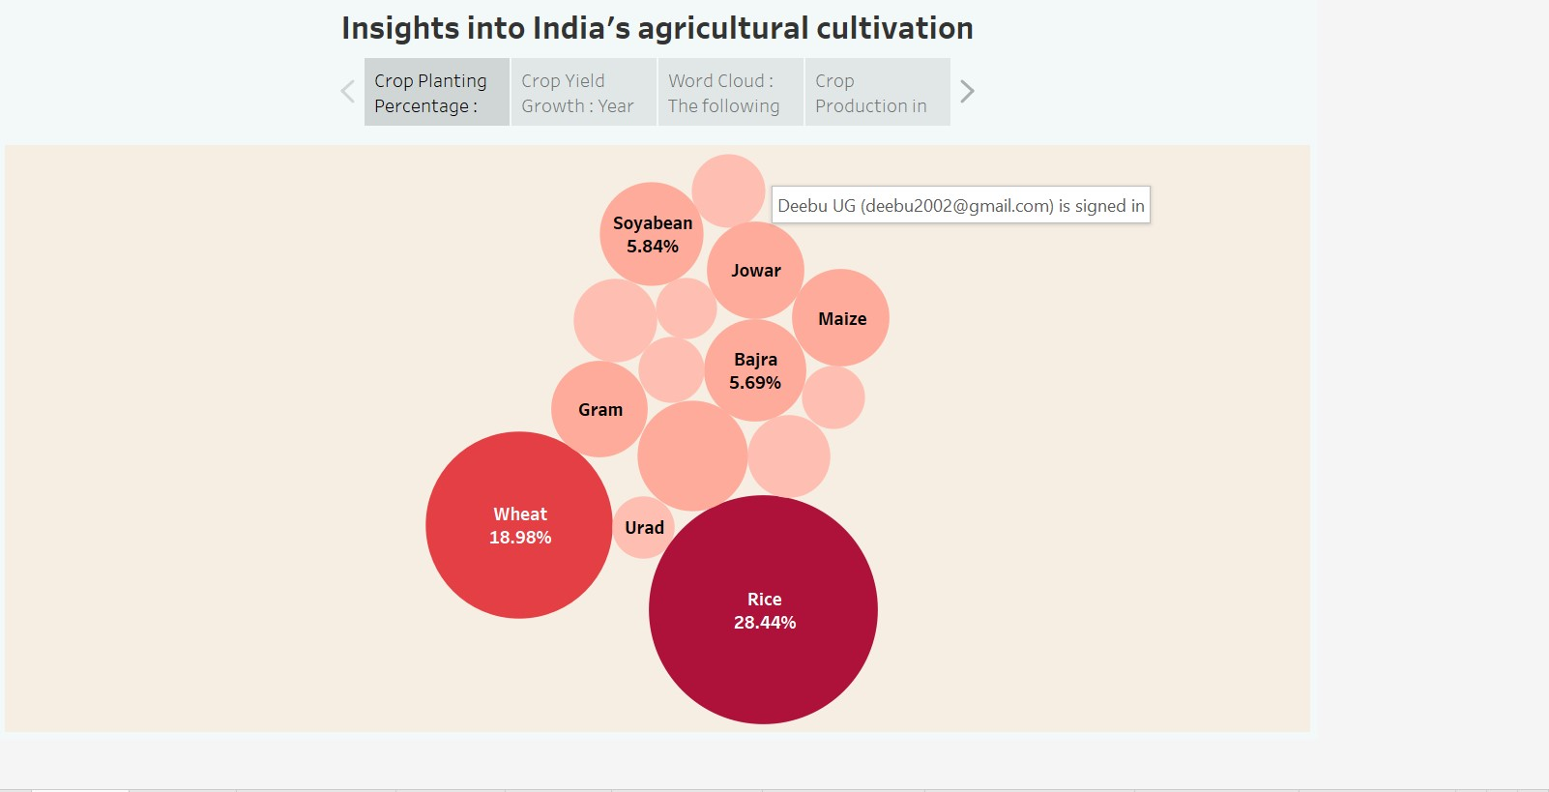

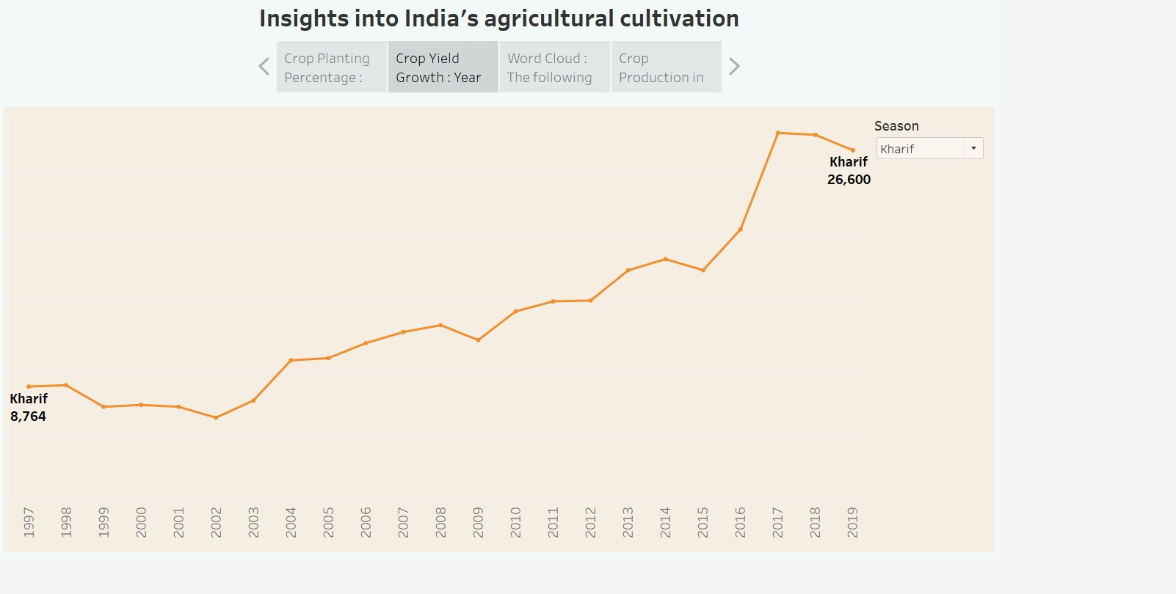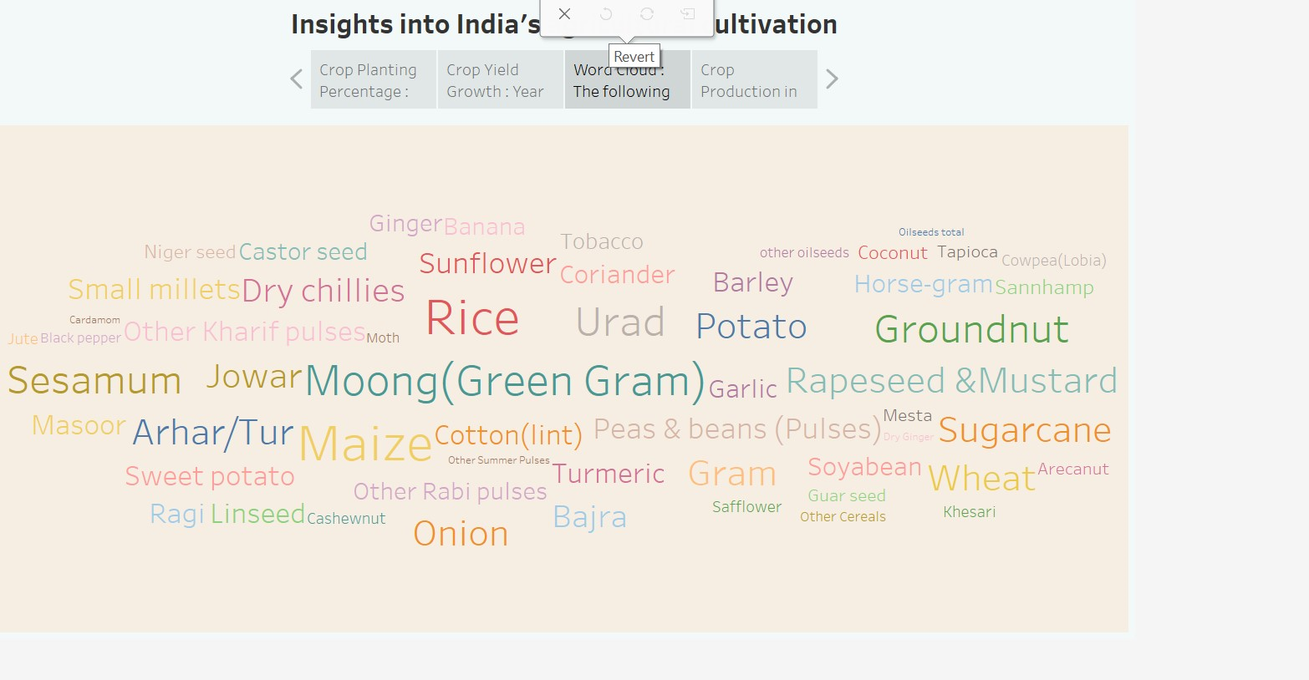

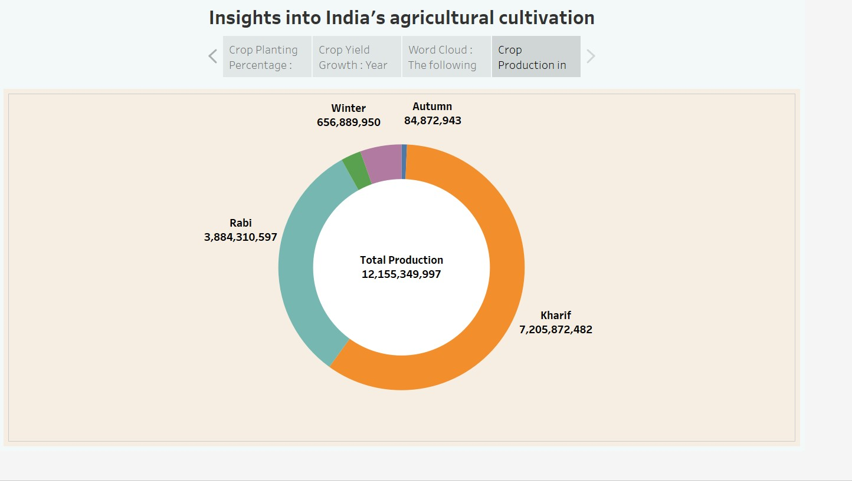

**4 ADVANTAGES & DISADVANTAGES**

**4.1 Advantages**

* Increased efficiency.
* Improved crop quality.
* Reduced environmental impact.
* Increased food production.
* Economic benefits.

**4.2 Disadvantages**

* Soil erosion.
* Irrigation problems.
* Lack of high quality seeds.
* Climate change.

**5 APPLICATIONS**

* Biotechnology and genetic engineering have resulted in pest resistance and increased crop yields.
* Enhancing soil quality.
* Modernisation in agriculture.
* Efficient markets.

**6 CONCLUSION**

Indian economy is predominantly dependent on the agricultural sector supports the industrial as well as international trade in both imports and exports. Even though the contribution of agriculture is reducing gradually, it is still the most important sector on which most of the working population depends on.

**7 FUTURE SCOPE**

* Studying the nature of the soil.
* Changing the traits of plants.



* Developing new varieties of plants.



* Studying the heredity of plants.
* Studying the causes of diseases in plants.

